Практикум по математическому анализу

Отчет о проделанной лабораторной работе №4

Выполнила Марина А. ПИН-14

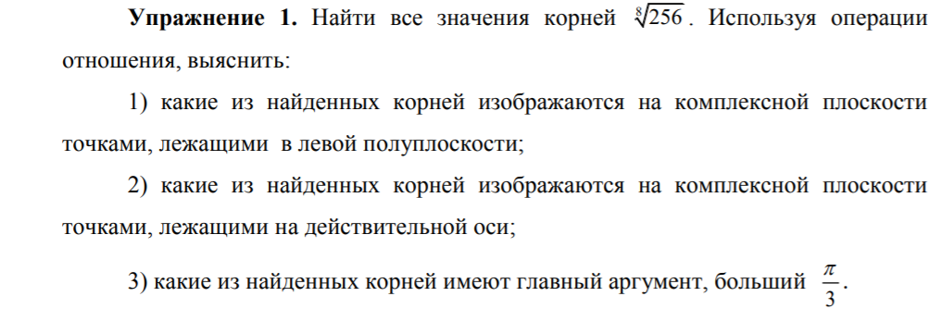

%Task 1

clear

disp('---Task 1---')

z=256

r=abs(z);

phi=angle(z);

k=1:1:8;

zroot=r^(1/8)*(cos((phi+2*pi*k)/8)+1i*sin((phi+2*pi*k)/8))

figure(1)

plot(real(zroot),imag(zroot),'or')

line([0 0],[-2 2],'Color','black')

line([-2 2],[0 0],'Color','black')

xlabel('Re'),ylabel('Im')

text(-1.400,1.400,'искомая точка(-1.414, 1.414)')

grid on

imag(zroot)==0

angle(zroot)>pi/3

Command window

---Task 1---

z =

256

zroot =

Columns 1 through 4

2 + 0i 1393/985 + 1393/985i * + 2i -1393/985 + 1393/985i

Columns 5 through 8

-2 + * -1393/985 - 1393/985i * - 2i 1393/985 - 1393/985i

Column 9

2 - *

ans =

1×9 logical array

1 0 0 0 0 0 0 0 0

ans =

1×9 logical array

0 0 1 1 1 0 0 0 0



…………………………………………………………………………………………………

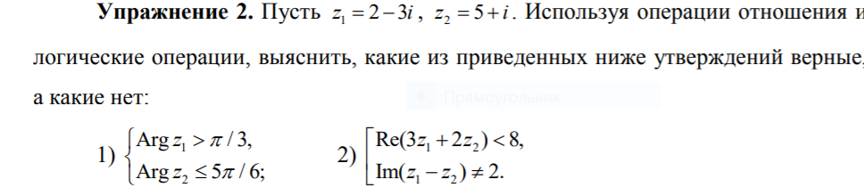

%Task 2

clear

disp('---Task 2---')

z1=2-3*1i

z2=5+1i

(angle(z1)>pi/3) &(angle(z2)<= 5*pi/6)

(real(3*z1+2*z2)<8) | imag(z1-z2)~=2

Command window

---Task 2---

z1 =

2.0000 - 3.0000i

z2 =

5.0000 + 1.0000i

ans =

0

ans =

1

……………………………………………………………………………………………………..

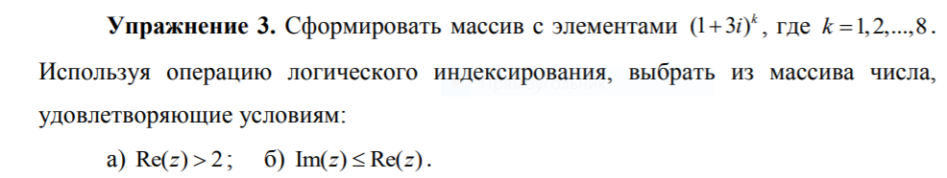

%Task 3

clear

disp('---Task 3---')

z=1+3*i

k=1:1:8;

format rational

S=z.^k

real(S)>2

B=real(S)>2

S(B)

R=imag(S)<=real(S)

S(R)

Command window

---Task 3---

z =

1 + 3i

S =

Columns 1 through 4

1 + 3i -8 + 6i -26 - 18i 28 - 96i

Columns 5 through 8

316 - 12i 352 + 936i -2456 + 1992i -8432 - 5376i

ans =

1×8 logical array

0 0 0 1 1 1 0 0

B =

1×8 logical array

0 0 0 1 1 1 0 0

ans =

28 - 96i 316 - 12i 352 + 936i

R =

1×8 logical array

0 0 0 1 1 0 0 0

ans =

28 - 96i 316 - 12i

……………………………………………………………………………………………………..

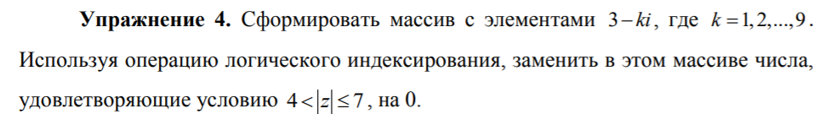

%Task 4

clear

disp('---task 4 ---')

k=1:1:9;

z=3-k*1i

B=abs(z)>4&abs(z)<=7

z(B)=0

Command window

---task 4 ---

z =

Columns 1 through 4

3 - 1i 3 - 2i 3 - 3i 3 - 4i

Columns 5 through 8

3 - 5i 3 - 6i 3 - 7i 3 - 8i

Column 9

3 - 9i

B =

1×9 logical array

0 0 1 1 1 1 0 0 0

z =

Columns 1 through 4

3 - 1i 3 - 2i 0 + 0i 0 + 0i

Columns 5 through 8

0 + 0i 0 + 0i 3 - 7i 3 - 8i

Column 9

3 - 9i

……………………………………………………………………………………………………...

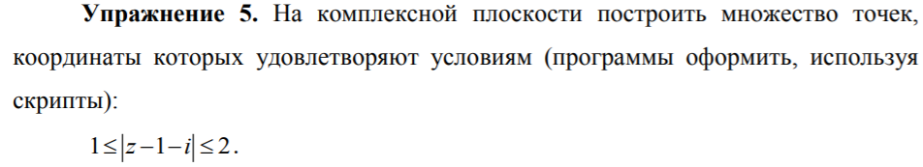

%Task 5

clear

disp('---Task5 ---')

x=3-6*rand(1,10^6);

y=3-6*rand(1,10^6);

z=x+1i*y;

figure(2)

A=abs(z-1-1i)>=1&abs(z-1-1i)<=2;

plot(x(A),y(A),'.')

grid on

axis equal

axis([-3 3 -3 3])

hold on

line ([-3 3],[0 0],'Color','k')

line ([0 0],[-3 3],'Color','k')

xlabel('Re(z)')

ylabel('Im(z)')

title('1<=|z-1-i|<=2')



***ЗАДАНИЯ ДЛЯ САМОСТОЯТЕЛЬНОЙ РАБОТЫ***

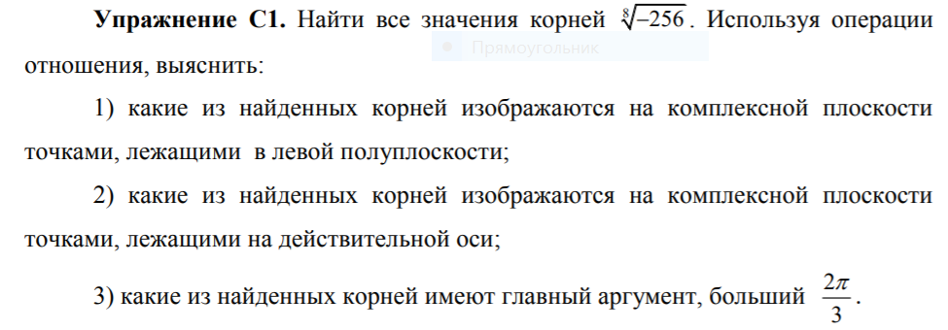

%Task 1

clear

disp('---Task 1---')

z=-256

r=abs(z);

phi=angle(z);

k=0:1:8;

zroot=r^(1/8)*(cos((phi+2*pi*k)/8)+1i*sin((phi+2*pi*k)/8))

figure(1)

plot(real(zroot),imag(zroot),'or')

line([0 0],[-2 2],'Color','black')

line([-2 2],[0 0],'Color','black')

xlabel('Re'),ylabel('Im')

text(-0.700,1.848,'(-0.700, 1.848)')

text(-1.800,0.7654,'(-1.800, 0.7654)')

text(-1.800,-0.7654,'(-1.800,-0.7654)')

text(-0.7654,-1.848,'(-0.7654,-1.800)')

grid on

imag(zroot)==0

angle(zroot)>2*pi/3

Command window

---Task 1---

z =

-256

zroot =

Columns 1 through 4

2391/1294 + 1158/1513i 1158/1513 + 2391/1294i -1158/1513 + 2391/1294i -2391/1294 + 1158/1513i

Columns 5 through 8

-2391/1294 - 1158/1513i -1158/1513 - 2391/1294i 1158/1513 - 2391/1294i 2391/1294 - 1158/1513i

Column 9

2391/1294 + 1158/1513i

ans =

1×9 logical array

0 0 0 0 0 0 0 0 0

ans =

1×9 logical array

0 0 0 1 0 0 0 0 0



…………………………………………………………………………………………………….

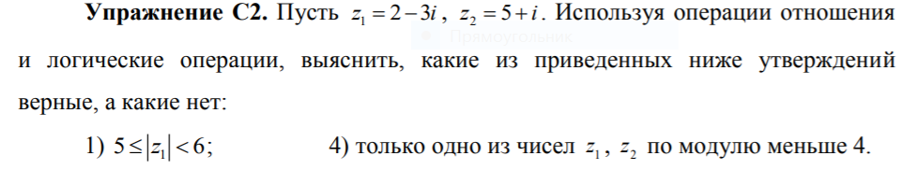

%Task 2

clear

disp('---Task 2---')

z1=2-3*1i

z2=5+1i

(abs(z1)>=5) & (abs(z1)< 6)

xor((abs(z1)<4),(abs(z2)<4))

Command window

---Task 2---

z1 =

2.0000 - 3.0000i

z2 =

5.0000 + 1.0000i

ans =

0

ans =

1

……………………………………………………………………………………………………...

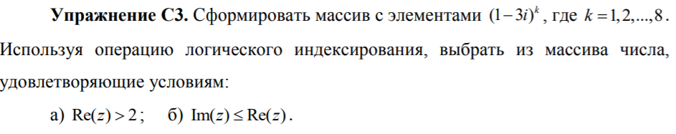

%Task 3

clear

disp('---Task 3---')

z=1-3*i

k=1:1:8;

format rational

S=z.^k

real(S)>2

B=real(S)>2

S(B)

R=imag(S)<=real(S)

S(R)

Command window

---Task 3---

z =

1 - 3i

S =

Columns 1 through 4

1 - 3i -8 - 6i -26 + 18i 28 + 96i

Columns 5 through 8

316 + 12i 352 - 936i -2456 - 1992i -8432 + 5376i

ans =

1×8 logical array

0 0 0 1 1 1 0 0

B =

1×8 logical array

0 0 0 1 1 1 0 0

ans =

28 + 96i 316 + 12i 352 - 936i

R =

1×8 logical array

1 0 0 0 1 1 0 0

ans =

1 - 3i 316 + 12i 352 - 936i

……………………………………………………………………………………………………...

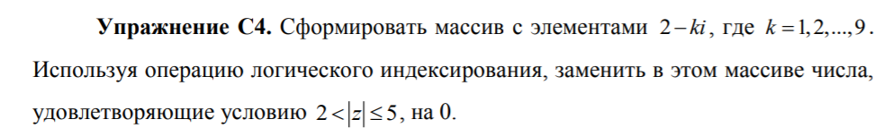

%Task 4

clear

disp('---task 4 ---')

k=1:1:9;

z=2-k*1i

B=abs(z)>2&abs(z)<=5

z(B)=0

Command window

---task 4 ---

z =

Columns 1 through 4

2 - 1i 2 - 2i 2 - 3i 2 - 4i

Columns 5 through 8

2 - 5i 2 - 6i 2 - 7i 2 - 8i

Column 9

2 - 9i

B =

1×9 logical array

1 1 1 1 0 0 0 0 0

z =

Columns 1 through 4

0 + 0i 0 + 0i 0 + 0i 0 + 0i

Columns 5 through 8

2 - 5i 2 - 6i 2 - 7i 2 - 8i

Column 9

2 - 9i

……………………………………………………………………………………………………

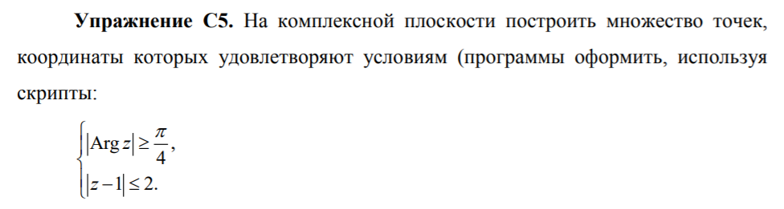

%Task 5

clear

disp('---Task5 ---')

x=3-6*rand(1,10^6);

y=3-6*rand(1,10^6);

z=x+1i*y;

figure(2)

A=abs(z-1)<=2&abs(angle(z))>=pi/4;

plot(x(A),y(A),'.')

grid on

axis equal

axis([-3 3 -3 3])

hold on

line ([-3 3],[0 0],'Color','k')

line ([0 0],[-3 3],'Color','k')

xlabel('Re(z)')

ylabel('Im(z)')

title('---task 5---')

Command window



*Замечание.* Если логические операции применить к числовым переменным,

то 0 будет рассматриваться как ложь, а все остальные числа как истина.